**M2 – Normal modes in an acoustic chamber**

**Declan Healy 21061669**

**Monday group**

28/11/2022 Week 7 and 8

Aims and objectives (A&O)

This experiment intends to explore acoustic phenomena in an acoustic chamber, specifically the occurrence of normal modes across a range of frequencies.

With a chamber of measured dimensions, predictions can be made of the frequencies the sound wave generated will resonate i.e. the modes.

Risk Assessment (RA)

There is not perceived to be any significant risks involved while performing this experiment.

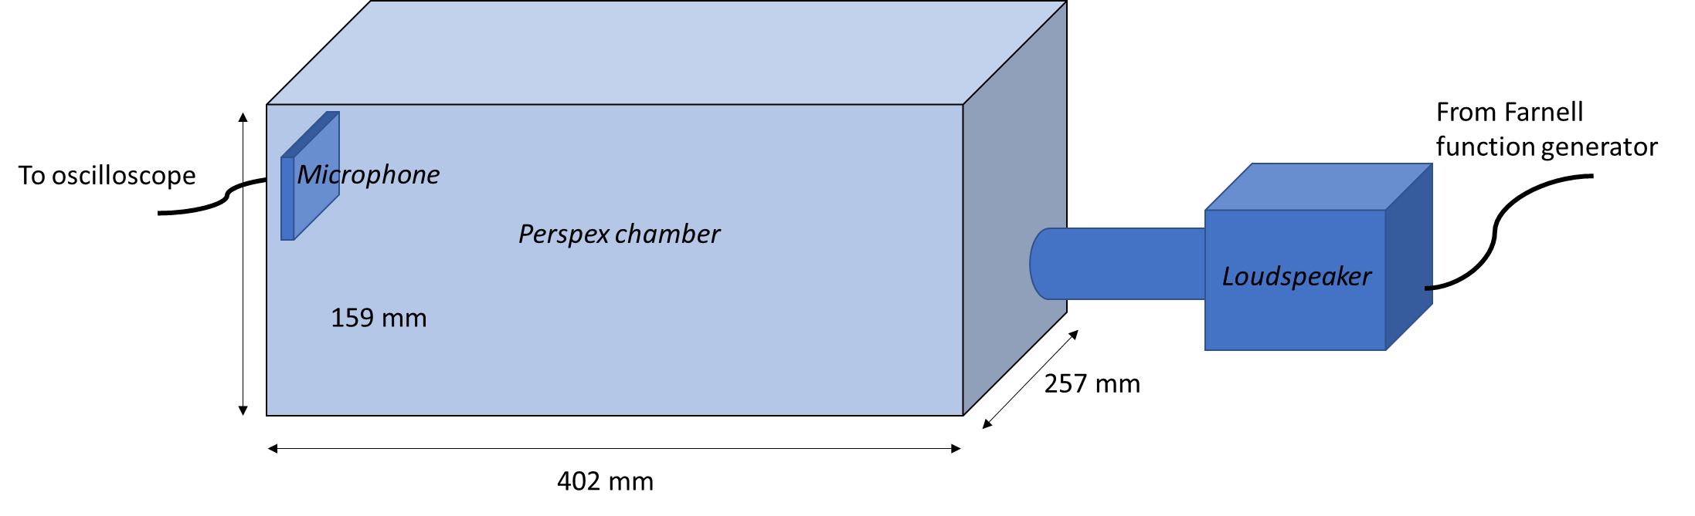**Apparatus**

*Figure 1: setup of the equipment used in this experiment*

Sound was generated via loudspeaker connected to a Farnell function generator.

Sound waves from this were picked up by the microphone at the other end of the Perspex chamber.

The resulting waves were displayed on a digital oscilloscope screen where frequency and amplitude of the wave could be measured. The Farnell function generator was also connected to the oscilloscope so that the input and output waves could be displayed side by side, and comparisons such as the phase difference could be made.

Experiment section

Initially, the internal dimensions of the Perspex chamber and the length of the tubes were measured using a ruler. A ruler has an error of ±0.5mm at each end of its measurement, resulting in a total error of ±1mm. The Perspex chamber was measured to have dimensions of (257±1) mm by (402±1) mm by (159±1) mm.

Using these dimensions, the predicted frequencies were calculated using the following formula:

$$f=\frac{c}{2}\sqrt{\frac{{n_{x}}^{2}}{{L_{x}}^{2}}+\frac{{n_{y}}^{2}}{{L_{y}}^{2}}+\frac{{n_{z}}^{2}}{{L_{z}}^{2}}}$$

Where f is frequency, c is the speed of sound in the chamber, Lx, Ly and Lz are the chamber’s internal dimensions and nx, ny and nz are integers that describes which mode the frequency is being calculated for (i.e. (1,0,0) is the fundamental, which is one half-wavelength along the side Lx.

These calculations were done in Excel with the possible permutations of n generated with [numbergenerator.org](https://numbergenerator.org/permutations-and-combinations). These calculations produced a table of predicted up to 1500 Hz shown below:

|  |  |  |  |
| --- | --- | --- | --- |
| nx | ny | nz | frequency /Hz |
| 0 | 1 | 0 | 426.39 |
| 1 | 0 | 0 | 666.95 |
| 1 | 1 | 0 | 791.60 |
| 0 | 2 | 0 | 852.77 |
| 0 | 0 | 1 | 1078.03 |
| 1 | 2 | 0 | 1082.61 |
| 0 | 1 | 1 | 1159.29 |
| 1 | 0 | 1 | 1267.67 |
| 0 | 3 | 0 | 1279.16 |
| 2 | 0 | 0 | 1333.91 |
| 1 | 1 | 1 | 1337.45 |
| 0 | 2 | 1 | 1374.54 |
| 2 | 1 | 0 | 1400.40 |
| 1 | 3 | 0 | 1442.59 |

*Table 1: predicted frequency of normal modes in the Perspex chamber*

After the apparatus was setup as shown in figure 1 and all the equipment was turned on, the frequency generated by the Farnell function generator was set to around 400 Hz: just below the predicted frequency of the fundamental, in order to account for errors.

It was observed that the wave displayed on the oscilloscope screen becomes noisier, and less stable, at lower frequencies. This would mean that the uncertainty of measurements increase as frequency is lowered.

The frequency was then slowly increased until the amplitude reach a localised maximum, and the location of this was recorded. This was done up to 1500Hz, and the entire process repeated with the short, medium and long pipes. The results are displayed in table 2.

|  |  |  |
| --- | --- | --- |
| short | medium | long |
| 450 | 450 | 448 |
| 691 | 690 | 689 |
| 811 | 813 | 813 |
| 875 | 869 | 869 |
| 1106 | 1079 | 920 |
| 1183 | 1122 | 1105 |
| 1296 | 1284 | 1289 |
| 1347 | 1344 | 1346 |
| 1398 | 1386 | 1385 |
| 1425 | 1423 | 1422 |
| 1464 | 1459 | 1456 |

*Table 2: measured frequencies, in Hertz, of the normal modes in the Perspex chamber with a short (69±1) mm, medium (145±1) mm and long (179±1) mm pipe connected*

The frequency range of 1300Hz to 1400Hz was then explored in more detail, with the amplitude of the wave recorded at small incremental frequencies throughout this range. The Vpp measure on the digital oscilloscope was used to record the amplitude from the microphone.

Experiment section

Conclusions

For week 1

**Date and week number**

**Aims and objectives** – update

**Risk assessment** – update only if necessary

**Apparatus** – Update only if necessary

**Experimental section**

**Conclusions** – for the whole experiment.